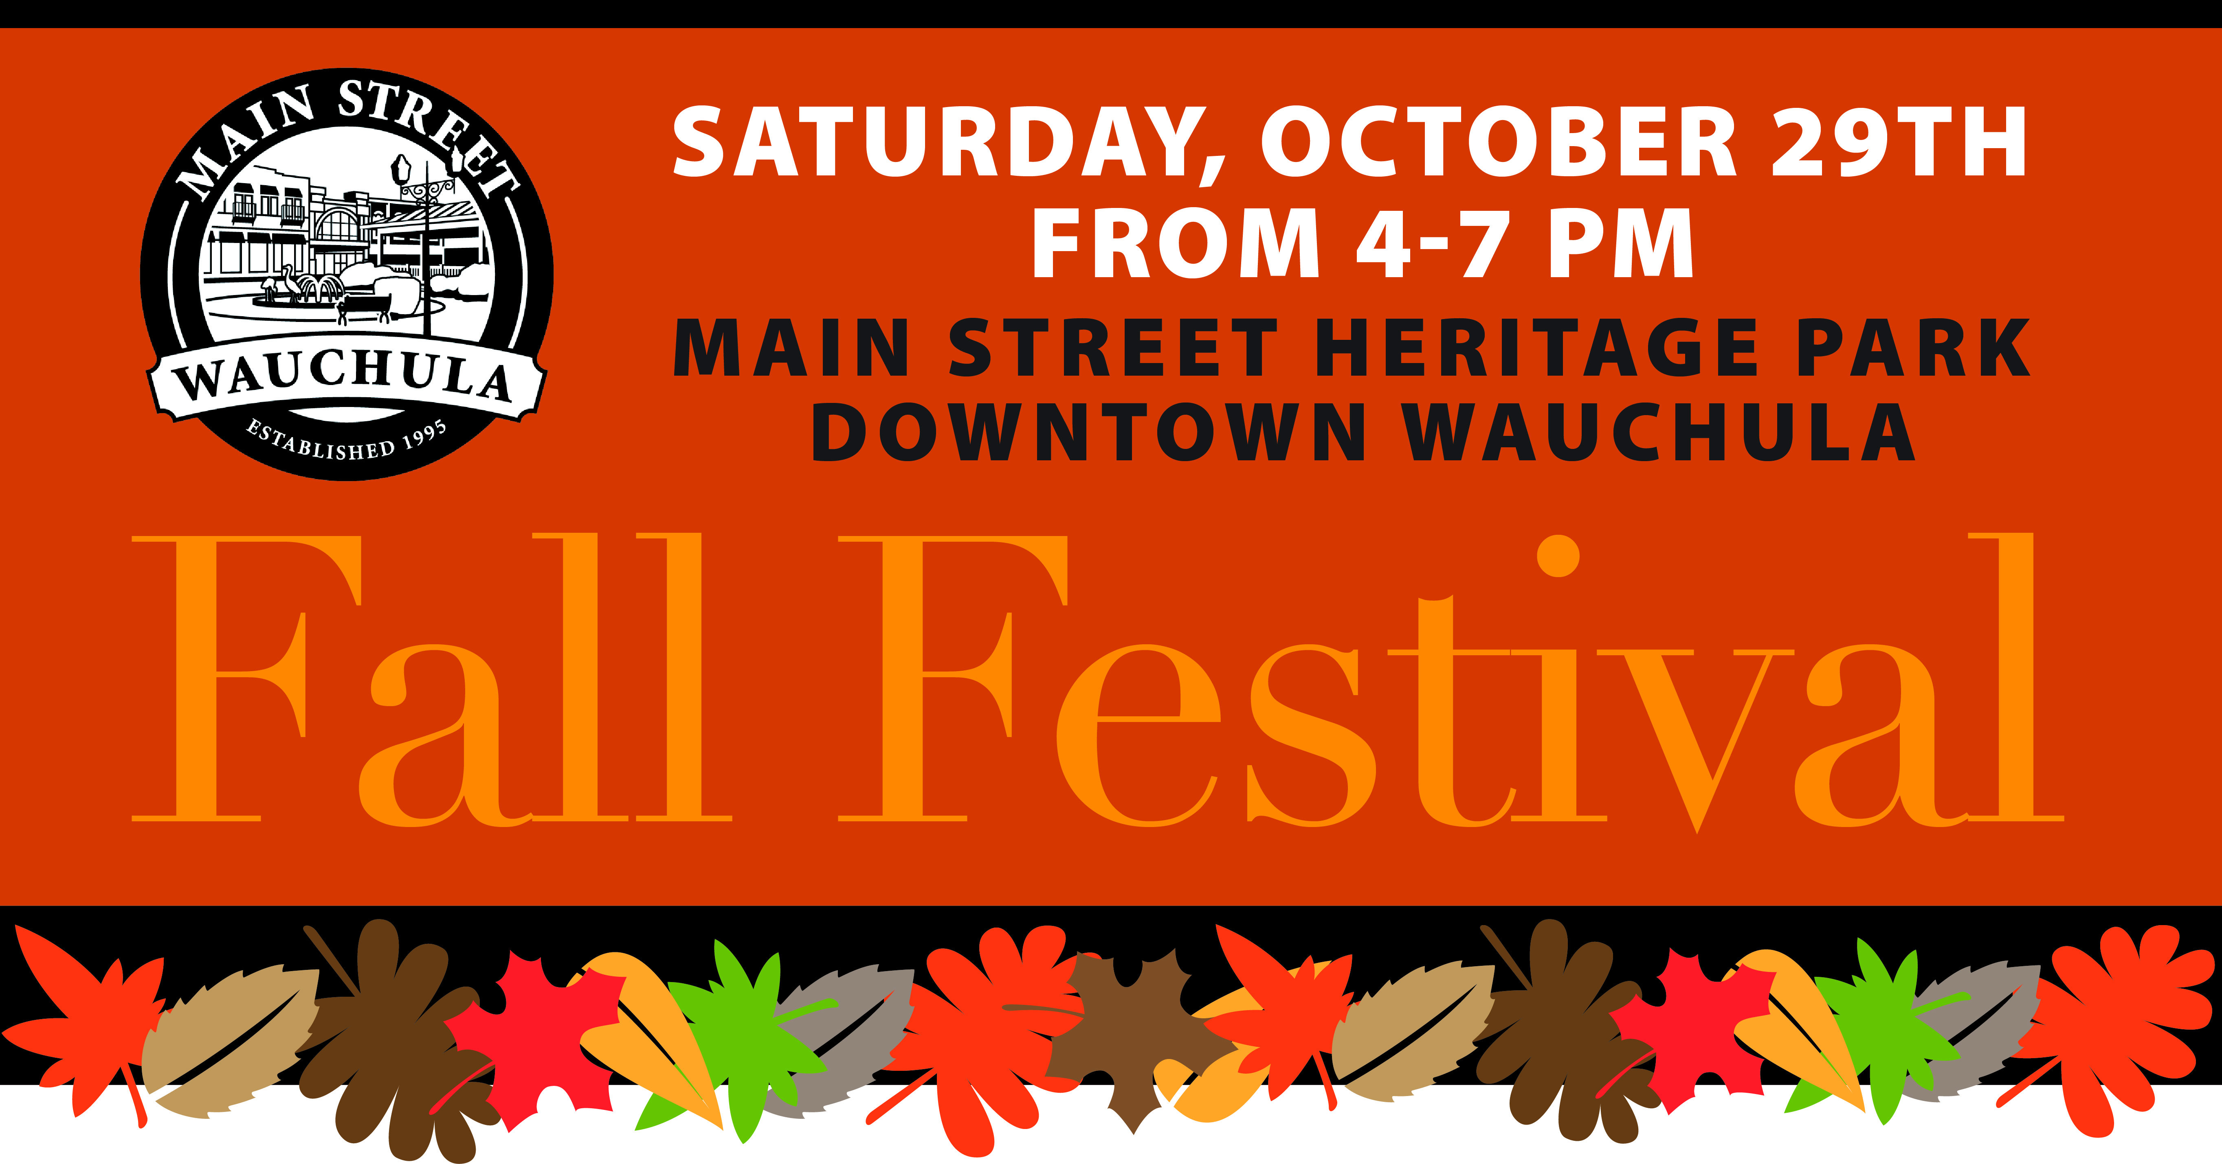

**Sign up to volunteer at the Community Fall Festival by listing your name, email address & telephone #. Please include the # that matches up with your preferred area to serve. For more details about each volunteer opportunity visit**

[**www.sendmemissions.com**](http://www.sendmemissions.com) **or email smm@sendmemissions.com**

1. **Game Booth** – We are looking for kid-friendly people, who will oversee a game booth by engaging and interacting with children through 5th grade. (time slots to be determined by local church)
2. **Evangelism** – We are looking for friendly people, who are willing to serve the Church by starting faith conversations with adults at the Fall Festival. We have a strategic plan to deploy volunteers to be successful witnesses at this event. There will be a short informational/training meeting to equip those willing to serve in this area on Thursday, October 27th from 6pm – 7pm at Florida’s First Assembly. Please include your t-shirt size when signing up. You will be contacted by Pastor David Adams if you sign up for this area.

**Name Email Address Telephone# # Area to Serve**

(John Smith) ([johnsmith@yahoo.com](mailto:johnsmith@yahoo.com)) (863-773-9999) (#2) (include shirt size if #2)

________________________________________________________________________________________________________________________________________________________________________________________________________________________________________________________________________________________________________________________________________________________________________________________________________________________________________________________________________________________________________________________________________________________________________________________________________________________________________________________________________________________________________________________________________________________________________________________________

Candy Donations are needed!